**Day 5**

**The AI Project Cycle**

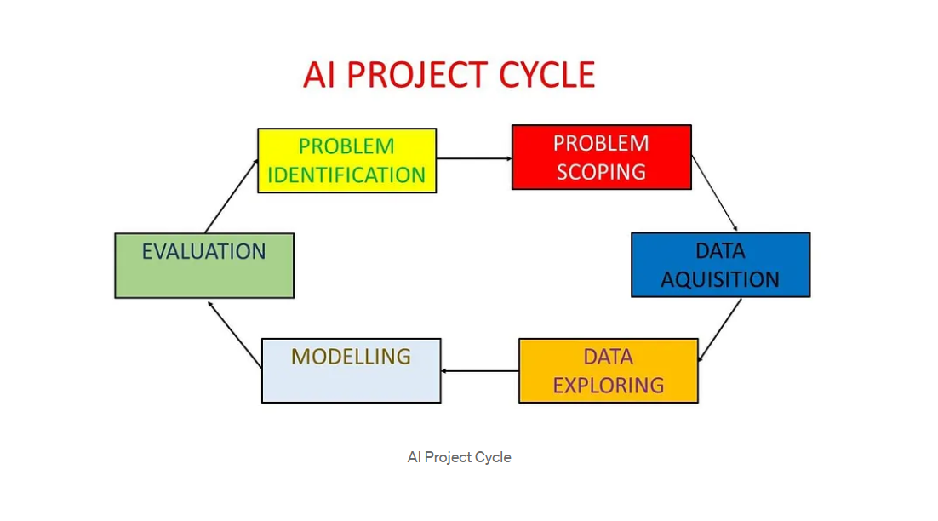

The AI Project Cycle is a cycle/order of an AI Project which defines every step an organization must take to harness/get value (Monetary or others) from that AI Project to get more ROI (Return on Investment).

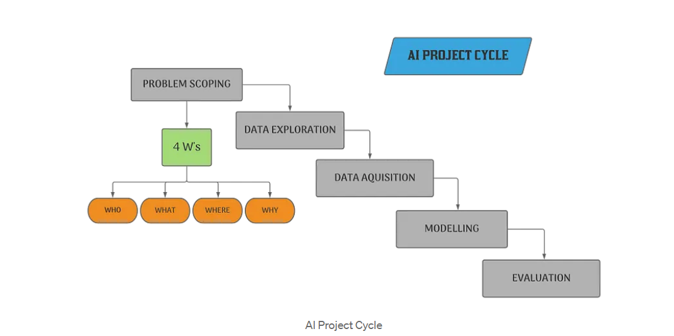

You might have seen AI Project Cycle images Starting from ‘Problem Scoping’, ignoring ‘Problem Identification’, But in this article we will discuss about the one with ‘Problem Identification’ which is a more accurate representation.

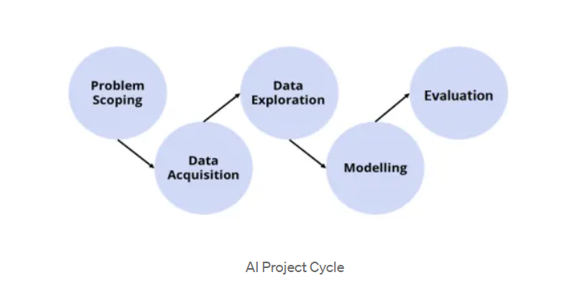

**Problem Scoping:**Whenever we are starting any work, certain problems always associated with the work or process. These problems can be small or big, sometimes we ignore them, sometimes we need urgent solutions. Problem scoping is the process by which we figure out the problem that we need to solve.



**The 4Ws Canvas:**The 4Ws Canvas is a helpful tool in Problem Scoping. Basically, questions which help us understand the problems in a better, more structured way.

* **Who?:** Refers that who is facing a problem, who the stakeholders of the problem are and who are affected because of the problem.
* **What?:**Refers to what the problem is and what you know about the problem. What is the nature of the problem? Can it be explained simply? How do you know it’s a problem? What is the evidence to support that the problem exists? What solutions are possible in this situation? etc. At this stage, you need to determine the exact nature of the problem.
* **Where?:**It is related to the context or situation or location of the problem, focus on the context/situation/location of the problem.
* **Why?:**Refers to the reason we need to solve the problem, the benefits which the stakeholders would get from the solution and how would it benefit them as well as the society, what are the benefits to the stakeholders after solving the problem.

**Data Acquisition:**Data Acquisition consists of two words:

* **Data:** Data refers to the raw facts, figures, information, or statistics.
* **Acquisition:** Acquisition refers to acquiring data for the project.

So, Data Acquisition means Acquiring Data needed to solve the problem.

DATA MAY BE THE PROPERTY OF SOMEONE ELSE, AND THE USE OF THAT DATA WITHOUT THEIR PERMISSION IS NOT ACCEPTABLE.

But there are some sources from which we can collect data, no hassle whatsoever. Let’s Take a Look:

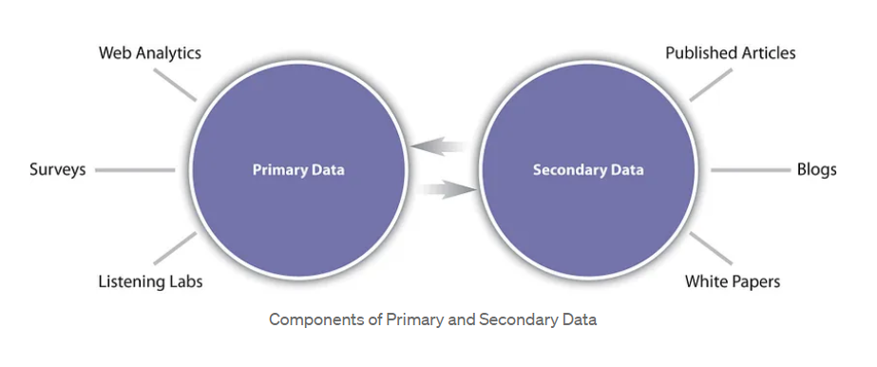

**Data Exploration:**Data exploration is the first step of data analysis which is used to visualize data to uncover insights from the start or identify areas or patterns to dive into and dig more. It allows for a deeper, more detailed, and better understanding of the data. Data Visualization is a part of this where we visualize and present the data in terms of tables, pie charts, bar graphs, line graphs, bubble chart, choropleth map etc. For a full list of the different Data Visualization tools, click [here](https://datavizcatalogue.com/). This provides a common, consistent, and predictable way of defining and managing data resources.

**Modelling:**First of, what is an AI Model? An AI model is a program or algorithm that utilizes a set of data that enables it to recognize certain patterns. This allows it to reach a conclusion or make a prediction when provided with sufficient information. Now, what is Modelling? Modelling is the process in which different models based on the visualized data can be created and even checked for the advantages and disadvantages of the model.

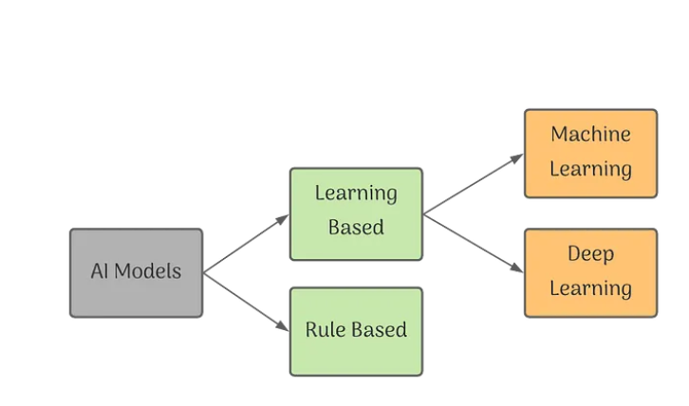

* **Supervised Learning:** The data that you have collected here is labelled and so you know what input needs to be mapped to what output. This helps you correct your algorithm if it makes a mistake in giving you the answer. Supervised Learning is used in classifying mail as spam.
* **Unsupervised Learning:**The data collected here has no labels and you are unsure about the outputs. So, you model your algorithm such that it can understand patterns from the data and output the required answer. You do not interfere when the algorithm learns.
* **Reinforcement Learning:** There is no data in this kind of learning, you model the algorithm such that it interacts with the environment and if the algorithm does a decent job, you reward it, else you punish the algorithm. (Reward or Penalty Policy). With continuous interactions and learning, it goes from being bad to being the best that it can for the problem assigned to it.

**Evaluation:** The method of understanding the reliability of an API Evaluation and is based on the outputs which is received by the feeding the data into the model and comparing the output with the actual answers.

**Deployment:**Deployment is the method by which you integrate a machine learning model into an existing production environment to make practical business decisions based on data.

To start using a model for practical decision-making, it needs to be effectively deployed into production.

If you cannot reliably get practical insights from your model, then the impact of the model is severely limited, and it is useless.

To get the most value out of machine learning models, it is important to seamlessly deploy them into production so a business can start using them to make practical decisions.

A report showed that for 40% of companies the process of deploying an ML model took more than a month, for 28% of companies it required 8 to 30 days and for 14% it took less than a week.